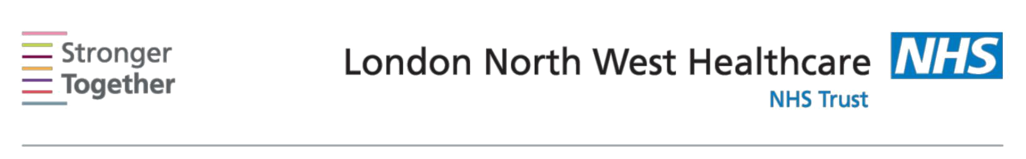
Nutrition and Dietetic Department, Northwick Park Hospital, Tel: 0208 869 2666

First line advice:
For Patients with Anaemia or a low Iron Intake
This information sheet has been provided to give you basic initial information about what to do if you are suffering from iron deficiency anaemia or have a low iron intake. If you need more detailed advice and support, please ask your doctor to refer you to a dietitian.

Iron is an important part of the blood as it carries oxygen in blood around the body. If you do not have enough iron in your diet you may develop iron deficiency anaemia. Iron deficiency can make people feel tired, irritable and lack concentration. Women have higher requirements than men, partly because of iron losses in menstruation.

Most people can get enough iron from their diets and there are also ways to improve the absorption of iron in your body. Below is a list of foods containing iron & some of the ways you can improve your absorption.

Iron from meat is more easily absorbed by the body, so if you are vegetarian or eat very little meat/ fish or eggs you should pay extra attention to ways to improve absorption.

The following foods are good sources of iron:

Meat/Non Vegetarian sources | Vegetarian sources
Red meat e.g. Lamb, beef, minced | Beans & Pulses e.g. baked
beef | beans, dhal, kidney beans, mung
 | beans, chickpeas, hummus
Liver & Kidney Note: pregnant | Nuts & seeds e.g. Almonds,
women are advised to avoid liver | cashew, walnuts, sesame seeds
Seafood e.g. prawns, mussels, | Fortified & wholegrain: cereals,
anchovies, | breads & flours
Oily fish e.g. mackerel, tuna, salmon, | Dark green leafy vegetables &
sardines | dried fruits e.g. Spinach, broccoli,
 | spinach, spring greens, kale,
 | okra, apricots, prunes, figs,
 | raisins
Eggs | Soya beans, tofu
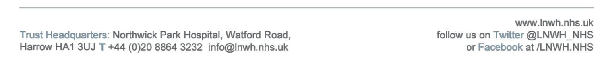
Information for patients

To improve iron absorption into the body:

Tannin in tea reduces iron absorption. Try to avoid taking tea with meals

Vitamin C in fruit and vegetables helps iron absorption from meals:

- Have fruit and vegetables with meals. Try to avoid overcooking vegetables as this will reduce the Vitamin C content. Try steaming or microwave instead of boiling – or use small amount of water if boiling over a short time.
- Drink a small glass of unsweetened fruit juice with meals instead of tea.
- Add salads to meals
- Store fruit & vegetables in a cool, dark place

This information leaflet was produced by the Community Dietitians at The London North West Healthcare NHS Trust, Northwick Park Hospital, Watford Rd, Harrow, HA1 3UJ


This information sheet was produced by the Community Dietitians at Northwick Park Hospital and is intended to be given by a health professional only. It is not a substitute for proper medical diagnosis or dietary advice given by a Registered Dietitian. The advice is not appropriate for certain medical conditions such as diets that require the exclusion or restriction of particular foods. If in doubt, please check with your medical practitioner.

Last review January 2014

Review date January 2016 Reference: Fe2014

