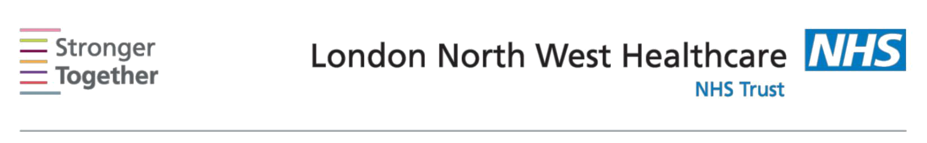
Nutrition and Dietetic Department, Northwick Park Hospital, Tel: 0208 869 2666

First line advice:
For Patients Needing to Reduce Weight
This information sheet has been provided to give you basic initial information about what to do if you have a Body Mass Index (BMI) of greater than 25kg/m2 (overweight) or greater than 30kg/m2 (obese). If you need more detailed advice and support, please ask your doctor to refer you to a dietitian.

The amount of energy (calories) you take in by eating is usually ‘balanced’ by the amount of energy you use up in everyday living. This results in having a stable weight. Any excess energy is stored as body fat. This happens if the amount of energy taken in is greater than the amount of energy burned.

In order to lose weight, energy intake should be reduced and combined with increased daily activity.

Aim for realistic weight loss targets

Even a small weight loss can benefit your health. Aim for 1/2-1kg (1-2lbs) loss per week. Achieving 5-10% weight loss in 3-6 months can reduce your risk of some chronic conditions such as Type 2 Diabetes and high blood pressure. For example, if you weigh 100kg, this means losing 5-10kg, or if you weigh 80kg, this means losing 4-8kg.

Benefits of weight loss and active lifestyle: (Tick those you feel will apply to you)

o Clothes fit better

o Less short of breath o More energy
o Improved diabetic control/ reduced risk of developing diabetes o Lowers cholesterol level
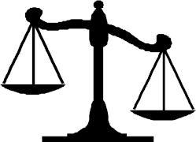
o Improves blood pressure o Less joint and back pain o Move around more easily
o Reduced risk of developing certain cancers

Dietary Change | Why?

Regular balanced Have three meals every 4-5 hours (see portion plate below) meals Try to avoid other activities at mealtimes, such as watching

TV or working, to help you to recognise when you are full. Eating regularly prevents feeling hunger which can lead to snacking on unhealthy options. Missing food groups can lead to overeating and increased snacking.

Balanced meals help to ensure a good intake of nutrients
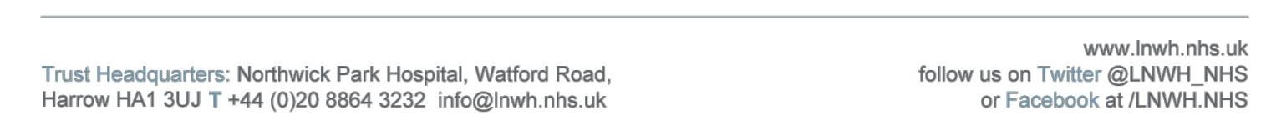
Information for patients

Avoid foods high in |  |  | These foods & drinks are high in calories even in small
fats and/or sugar |  |  | amounts.
 |  |  | Limit the amount you have or use low fat/sugar alternative
 |  |  | where possible, for example low sugar drinks, low fat yogurt.
 |  |  | Small changes can add up to big calorie differences.
Watch your portions |  |  | Large portion sizes can result in large amounts of calories.
 |  |  | Try to use a smaller plate and follow the plate guide for
 | Carbohydrate |  | quantities on the plate.
 |  |  | Aim for your plate to be balanced as shown (palm size of
 | (Potato, pasta, |  | carbohydrate, palm size of protein & ½ a plate of
 | Rice, bread) |  | vegetables).
Vegetables |  |  | vegetables).
 | Protein |  | Vegetables tend to be very low in calories so have a large
 |  |  | portion.
 | (meat, fish, |  | portion.
 | eggs, beans,
 | Pulses)
Snack check |  |  | Think! Are you hungry or thirsty? Try having a drink first.
 |  |  | Healthy snacks such as low fat yogurt, piece of fruit, small
 |  |  | handful of plain nuts, vegetable sticks, or rice cakes.
 |  |  | High calorie snacks like biscuits/chocolate/cheese can
 |  |  | prevent weight loss and can cause weight gain.
Drink plenty of |  |  | Aim for about 6-8 glasses/day. Choose low or zero calorie
fluids |  |  | fluids such as water, low sugar squash, flavoured water,
 |  |  | tea/coffee.
 |  |  | Have a drink with your meal to help you feel fuller.
 |  |  | Alcohol is high in calories. Try limiting how often you drink
 |  |  | alcohol or reduce its quantity.
 |  |  | 1 large glass wine/ 1 pint 4% beer = approximately 200
 |  |  | calories
Include more low |  |  | Low GI foods are digested slowly & can help you stay fuller
Glycaemic Index |  |  | for longer.
(GI) foods and high |  |  | This can include seeded breads, oats, breakfast cereals with
fibre foods |  |  | dried fruit, pasta, beans, pulses, most vegetables, fruit loaf,
 |  |  | teacakes, and yoghurts.
 |  |  | You could also try swapping for brown rice, pasta, bread to
 |  |  | increase your fibre intake.
30 min activity daily |  |  | All activity causes you to burn calories and is beneficial for
 |  |  | weight loss. Aim for 30 min/ day minimum. This could
 |  |  | include brisk walking, housework, taking stairs instead of
 |  |  | lifts, dancing, swimming, and sport.
Get motivated & |  |  | Are there times when you eat and you are not hungry?
understand your |  |  | Think about why you are eating in these circumstances &
eating behaviour |  |  | what you could do to instead.
 |  |  | Try keeping a diary & log how you are feeling/ why you are
 |  |  | eating. This can help you understand your eating patterns.
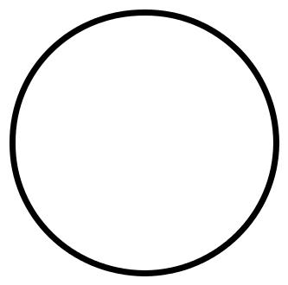
This information leaflet was produced by the Community Dietitians at The London North West Healthcare NHS Trust, Northwick Park Hospital, Watford Rd, Harrow, HA1 3UJ

This information sheet was produced by the Community Dietitians and is intended to be given by a health professional only. It is not a substitute for proper medical diagnosis or dietary advice given by a Registered Dietitian. The advice is not appropriate for certain medical conditions such as diets that require the exclusion or restriction of particular foods. If in doubt, please check with

your medical practitioner.
Last review January 2014

Review date January 2016 Reference: WtR2014

