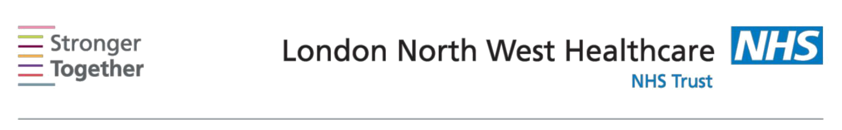
Nutrition and Dietetic Department, Northwick Park Hospital, Tel: 0208 869 2666

First line advice:
For patients with a small appetite and weight loss
This information sheet has been provided to give you basic initial information about what to do if you are suffering from a reduced appetite and you need to increase the energy and protein content of your diet to prevent weight loss. It is only intended for use until you can see a dietitian and is not intended to replace any advice that your dietitian will give you. Ensure your GP has booked you an appointment with a dietitian at the time you receive this sheet.

If you are suffering from a reduced appetite try these practical steps:

- Eat at the times you feel most hungry for example in the mornings or after light activity

- Try to eat small meals and nourishing snacks (see below for ideas) every 2-3 hours
- Include nourishing drinks every day for example milk or juice based drinks
- Try to place snacks where you spend a lot of time for easy reach

- Try having dessert after your meals, for example, sponge pudding/tarts/cakes with ice cream/custard/cream

- Alcohol in small amounts can stimulate your appetite (check with your doctor if this is contraindicated with your medication).

Fortifying your food

Full fat milk and dairy products can add extra calories and protein to your foods. Try adding the following to your meals:

o Add double cream to soups and sauces, potatoes and desserts o Add grated cheese to soups, sandwiches, pasta and potatoes o Add evaporated or condensed milk to desserts and drinks

- Add cream/yogurt/fromage frais to your cereals, puddings and desserts, soups and sauces.

- Add four tablespoons of dried milk powder to one pint of full fat milk to make Fortified Milk. Use this for cereals, puddings, drinks throughout the day.

Information for patients

Extra fats and sugars can add calories to everyday foods, examples include:

o Butter, margarine and oils
o Mayonnaise and salad dressings
o Peanut butter and chocolate spread
o Cream, cream cheese and crème fraiche

o White or brown sugar, or glucose powder (less sweet than sugar) o Jams and preserves, lemon curd, honey, syrup and treacle.
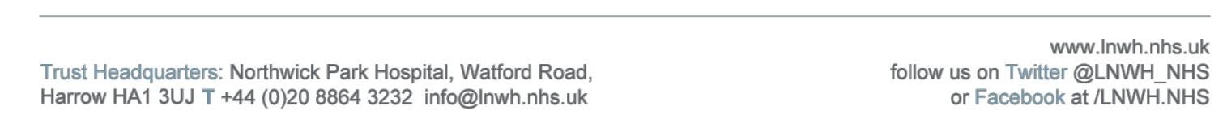

High calorie snacks between meals can boost your daily nutritional intake. Try these:

o Cakes, chocolates, oat/muesli bars, and pastries o Savoury biscuits (with cheese, pate, or dips)

o Crisps, nuts, savouries, and fried foods such as Bombay mix and samosas o Crumpets, tea-cakes, and fruit loaf

- Ready-made desserts such as trifle, rice pudding, mousse, crème caramel, and yogurt

Nourishing drinks can be helpful too. Below are some suggestions:

o Hot milky drinks such as hot chocolate, cocoa or malted drinks o Cold milkshakes or lassi with full fat yogurt
o Instant soups made with milk
o Fruit or vegetable juices, or smoothies

o Supplement drinks such as Complan®, Build-Up® or Recovery® o Avoid using sweeteners and sugar-free squash.

This information leaflet was produced by the Community Dietitians at The London North West Healthcare NHS Trust, Northwick Park Hospital, Watford Rd, Harrow, HA1 3UJ

This information sheet was produced by the Community Dietitians at Northwick Park Hospital and is intended to be given by a health professional only. It is not a substitute for proper medical diagnosis or dietary advice given by a Registered Dietitian. The advice is not appropriate for certain medical conditions such as diets that require the exclusion or restriction of particular foods. If in doubt, please check with your medical practitioner.

Last review January 2014 Review date January 2016 Reference:SAWL2014

