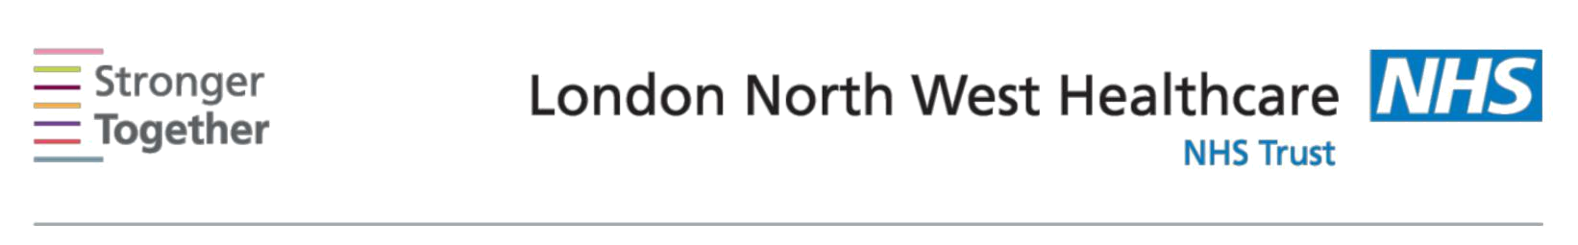
Nutrition and Dietetic Department, Northwick Park Hospital, Tel: 0208 869 2666

First line advice:
For Asian Patients with a small appetite and weight loss
This information sheet has been provided to give you basic initial information about what to do if you have a reduced appetite and you need to increase the energy and protein content of your diet to prevent weight loss.

Fortifying your food

Extra fats and sugars can add calories to everyday foods, examples include:

o Ghee, butter, margarine, vegetable oils, coconut oil, coconut cream o Full cream, full fat yoghurts, full cream milk
o White or brown sugar, gur, jams and honey

Fortify-

In addition to your meals, the following food products can be added to enhance the energy and protein content. Try adding 2 table spoons of one the following to your meals or snacks:

o Add double cream or skimmed milk powder to porridge, Weetabix or cornflakes o Add butter, ghee or vegetable oil to scrambled or fried eggs

o Add ghee to dhal, add creamed coconut to vegetable curry or meat curry o Add oil or ghee or butter to rice, kichdhi and chapattis
o Use full cream yoghurts in raitas and chutneys

- Add evaporated or condensed milk and ground almonds or desiccated coconut to milky puddings such as kheer, shikand, rasmalai and halwas

Snacks-
High calorie snacks between meals can boost your daily nutritional intake. Try these:

o Samosa, chatoris, puris, poppadums, kachoris, potato vada, veg bhaji o Savoury biscuits such as Ritz biscuits or rusks

o Chevda, Bombay mix, murukku, nuts and crisps. o Paneer, mogo, aloo tikka, vadai,
o Kheer, halwa, gulab jaman, kulfi, rasmalai and mitais.

Nourishing drinks-
These can be helpful too. Below are some suggestions:

o Hot milky drinks such as hot chocolate, Ovaltine, Horlicks or Milo o Cold milkshakes or lassi made with full fat yogurt

- Supplement drinks such as Complan®, Build-Up® or Recovery® (can be purchased over the counter)

- Add four tablespoons of dried milk powder such as Nido or Marvel to one pint of full fat milk to make high energy milk. The fortified milk can be used to make Indian tea, lassi or used in cereals, puddings or any other milky desserts.
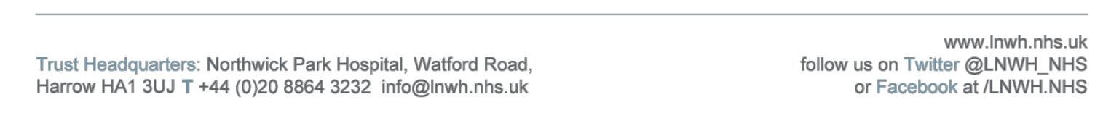

Information for patients

Eat little and often-
Try these practical steps:

- Eat at the times you feel most hungry for example in the mornings or after light activity
- Try to eat small meals and nourishing snacks every 2-3 hours
- Include nourishing drinks every day for example milk or juice based drinks
- Try to place snacks where you spend a lot of time for easy reach

- Try having dessert after your meals, for example, fruit or cakes with ice cream /custard/cream, or any milky desserts
- Have more milky tea or fortified milk.

This information leaflet was produced by the Community Dietitians at The London North West Healthcare NHS Trust, Northwick Park Hospital, Watford Rd, Harrow, HA1 3UJ

This information sheet was produced by the Community Dietitians at Northwick Park Hospital and is intended to be given by a health professional only. It is not a substitute for proper medical diagnosis or dietary advice given by a Registered Dietitian. The advice is not appropriate for certain medical conditions such as diets that require the exclusion or restriction of particular foods. If in doubt, please check with your medical practitioner.

Last review January 2014

Review date January 2015 Reference:SAWL2012

