
Nutrition and Dietetic Department, Northwick Park Hospital, Tel: 0208 869 2666

First line advice: For Patients Prescribed Supplement Drinks
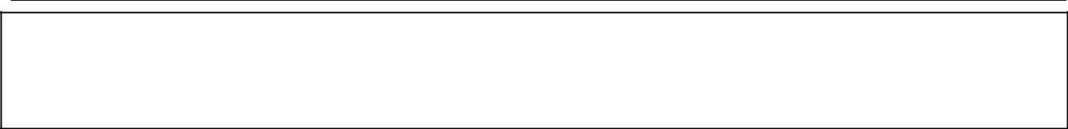
Your supplement
Product recommended ___________________Quantity per day_______________
Aim of treatment ____________________________________________________

Why do I need supplement drinks?

Supplement drinks are designed especially for people who are unwell and need an extra source of nutrition. They are enriched with vitamins, minerals and have additional protein and calories.

When you are unwell or recovering from injury or an operation, your body needs extra nutrition. It is best to meet your requirements with food and drinks. However, if you are unable to do so supplement drinks can provide extra nourishment. They are also useful if you have difficulty eating or swallowing which can affect the amount of food you eat. This can lead to weight loss and illness.

How and when do I take them?

Supplement drinks should be extra to your normal meals and should not replace meals. Take between meal times or before bed so they do not affect your appetite.

How do I get them?

Supplement drinks are available on prescription from your doctor. You will be given a small supply initially to see if you like them. You will then receive one month’s supply at a time and your doctor or dietitian will see you regularly to check they are still needed.

How do I store them?

Store in a cool, dry place. They do not need to be refrigerated. You can serve them chilled from the fridge, at room temperature or warmed gently. Check the use by date. Once opened, they must be stored in the fridge, and should be consumed in 24hrs or thrown away.

How long will I take them for?

Your healthcare team will set a goal weight or dietary intake and check your progress. It is important to remember that these drinks are only necessary in the short term during periods of illness. Once your goals have been met, you will no longer need them. If you wish to continue you could make your own nourishing drinks at home or alternatives are available to buy over the counter:
• | Complan | • | Build Up | • Nurishment
• | Nutrament | • | Supligen

This information leaflet was produced by the Community Dietitians at The London North West Healthcare NHS Trust, Northwick Park Hospital, Watford Rd, Harrow, HA1 3UJ
Information for patients

This diet sheet is intended for information only. It is not a substitute for proper medical diagnosis or dietary advice given by a Registered Dietitian. The advice is not appropriate for certain medical conditions such as conditions that require the exclusion or restriction of particular foods. If in doubt, please check with your medical practitioner.

Last review August 2012 Review date August 2014 Reference:
