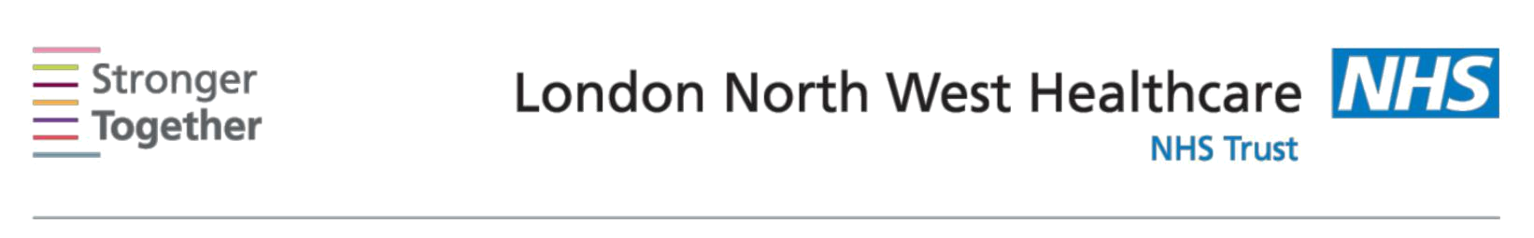
Nutrition and Dietetic Department, Northwick Park Hospital, Tel: 0208 869 2666

First line advice:
For patients with Irritable Bowel Syndrome (IBS)
This information sheet has been provided to give you basic initial information about what to do if you are suffering from Irritable Bowel Syndrome (IBS). If you need more detailed advice and support please ask your doctor to refer you to a Dietitian.

IBS is a common condition. Symptoms vary and may include: lower abdominal pain, bloating, wind, diarrhoea or constipation (or both alternating), feeling of urgency. Establishing a healthy lifestyle, including healthy eating, regular exercise and relaxation, often alleviates symptoms. You can get off to a good start by taking the following steps.

- Eat 3 regular meals a day based on starchy foods such as bread, chapatti, pasta, potato, rice and breakfast cereals. Try not to miss meals or eat late at night.

- Take time to eat meals. Sit down to eat and chew your food well.

- Drink at least 8 glasses/cups of fluid daily: water, diluted fruit juice, herb or fruit teas.

- Restrict tea and coffee to 3 cups a day or choose decaffeinated. Reduce fizzy drinks.

- Limit your alcohol intake. The recommended upper limit is 2-3 units of alcohol a day for a woman, 3-4 units for a man. Aim to have some alcohol-free days.

- Try recording a food and symptom diary so that you can remember which changes helped.

Next, make changes to your diet according to the symptoms you have now:

Constipation?
- Increase your fibre intake gradually.

- Choose wholemeal bread, wholegrain breakfast cereals, brown pasta and rice, medium brown chapatti. But do not add wheat bran to your foods.

- Aim for at least 5 portions of fruit and vegetables daily.
- Drink plenty of fluids spread throughout the day

Diarrhoea?

- Reduce your intake of high fibre foods eg wholegrain bread, cereals, rice, nuts and seeds

- Try white bread, rice and pasta, cornflakes, rice krispies, porridge.
- Avoid skins, pips and pith from fruit and vegetables
- Limit caffeine intake. Use decaffeinated versions of coffee, tea and cola.
- Avoid sugar-free sweets and chewing gum containing sorbitol

- Avoid fried foods eg chips, fast foods, burgers.and high fat snacks eg crisps and cake.
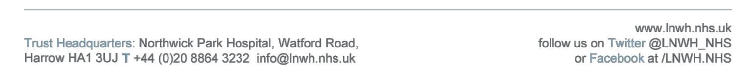
Information for patients

Abdominal pain, wind and bloating?

- Limit fruit (fresh dried or juice) to 3 portions daily. Make up remaining 5-a-day with vegetables.

- Try reducing foods containing ‘resistant starches’ such as reheated potato products (e.g. oven chips), part-baked breads, potato or pasta salad, and ready meals.

What about probiotics?

Some people find taking regular probiotic drinks or tablets help. There is insufficient evidence to recommend a specific probiotic product in IBS treatment. If you decide to try them, take them daily for at least four weeks.

What about Food Intolerance?

Occasionally symptoms of IBS are caused by a food intolerance. If you suspect wheat, talk to your GP about having a blood test to rule out coeliac disease. Continue to include wheat in your diet whilst you are awaiting the test.

You may be referred to a Dietitian for individual advice including manipulating the amount of fermentable carbohydrates in your diet. Do not restrict or avoid any major food (such as milk or wheat) without referral to a Registered Dietitian.

This information leaflet was produced by the Community Dietitians at The London North West Healthcare NHS Trust, Northwick Park Hospital, Watford Rd, Harrow, HA1 3UJ


This information sheet was produced by the Community Dietitians and is intended to be given by a health professional only. It is not a substitute for proper medical diagnosis or dietary advice given by a Registered Dietitian. The advice is not appropriate for certain medical conditions such as diets that require the exclusion or restriction of particular foods. If in doubt, please check with

your medical practitioner.

Last review January 2014

Review date January 2016 Reference: IBS2014

