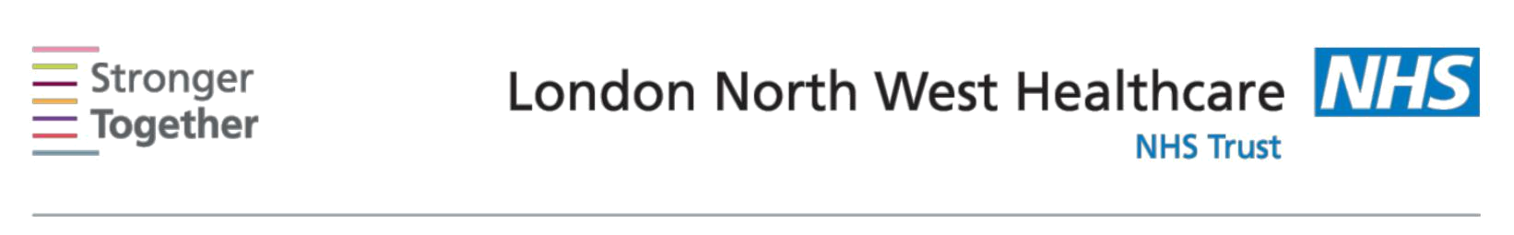
Nutrition and Dietetic Department, Northwick Park Hospital, Tel: 0208 869 2666

First line advice:
For Patients with Hypertension (High Blood Pressure)
This information sheet has been provided to give you basic initial information about what to do if you have Hypertension (High Blood Pressure). If you need more detailed advice and support, please ask your doctor to refer you to a dietitian.

Reducing your blood pressure can help lower the risk of coronary heart disease, stroke and kidney disease. Eating a balanced diet, cutting down on salt, taking regular exercise and aiming for a healthy body weight helps reduce blood pressure.

Cut down your salt |  |  | Avoid sprinkling salt on your meals and reduce salt
intake – as you do |  |  | added in cooking. Choose fresh foods where possible
this your taste will |  |  | as processed foods usually have a high salt content.
gradually adjust, and |  |  | Soups, crisps, savoury snacks, soya sauce, Marmite,
you should find that |  |  | gravy granules and stock cubes are all high in salt.
you prefer less salty |  |  | Experiment with flavouring foods using herbs and
food |  |  | spices, vinegars or lemon juice instead of salt and
 |  |  | stock cubes. Read food labels to select lower salt
 | Aim for less than |  | varieties:
 | 6g of salt each day.
 |  |  | HIGH salt | 1.5g or more per 100g
 |  |  | LOW salt | 0.3g or less per 100g
Aim for at least 5 |  |  | Fruit and vegetables are rich in fibre, vitamins and
portions of fruit and |  |  | minerals. Include at every meal and snack. Fresh,
vegetables every day |  |  | cooked, tinned, dried, juiced fruits and vegetables all
 |  |  | count.
If you drink alcohol, |  |  | Men and women should limit their intake to 2-3 units
keep to sensible |  |  | a day, with 2 alcohol free days per week. 1 unit of
limits |  |  | alcohol is a half-pint of beer, a small glass (125mls) of
 |  |  | wine, or single pub measure of spirits.
Aim for a healthy |  |  | If you are overweight, a steady rate of weight loss can
weight |  |  | reduce blood pressure. Following the advice below
 |  |  | will begin the change to a healthier diet.
Eat regular meals: |  |  | Starchy foods include bread, pasta, rice, potatoes,
aim for 3 meals, |  |  | chapatti, and cereals.
based on starchy
foods, evenly |  |  | Choose high fibre varieties of these foods where
distributed over the |  |  | possible such as wholegrain bread and breakfast
day |  |  | cereals. Reduce portion sizes if you are trying to lose
 |  |  | weight.
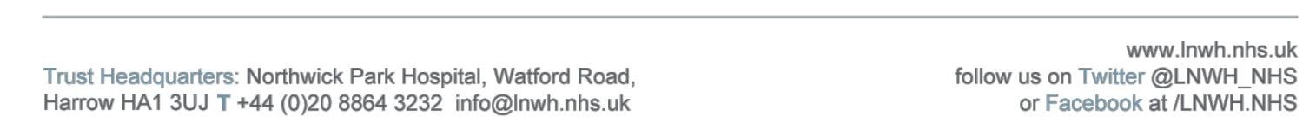
Information for patients

Eat less fat | Grill, boil, poach, steam or oven bake your food rather
especially saturated | than frying.
fat
 | Replace saturated fats (butter, lard, ghee) with
 | unsaturated fat spreads and oils but remember to limit
 | these to aid weight loss.
 | Choose leaner cuts of meat and meat products, and try
 | having fish twice a week, one of which should be oily.
 | Snacks such as sponge cakes, cream cakes, biscuits,
 | chocolate, Bombay mix, fried crisps etc are also high in
 | fat so should not be eaten regularly.
Include 3 servings | One serving is 1/3 pint of milk,125g of yoghurt, 2oz
of low fat milk and | cheese.
dairy products a | Use semi-skimmed or skimmed milk or soya milk
day | fortified with calcium. Choose reduced fat cheese and
 | diet yoghurts.
Eat fewer sugary | Cut down on sweet biscuits, cakes, sweets, and
foods and drinks | chocolate. Drink water, unsweetened juice, diet fizzy
 | drinks or sugar-free squashes. Try drinking tea and
 | coffee without sugar, or use an artificial sweetener
 | instead.
Be as physically | 30 minutes per day at least five times per week is
active as you can | recommended however check with your doctor first to
 | see what is appropriate for you.

This information leaflet was produced by the Community Dietitians at The London North West Healthcare NHS Trust, Northwick Park Hospital, Watford Rd, Harrow, HA1 3UJ

This information sheet was produced by the Community Dietitians and is intended to be given by a health professional only. It is not a substitute for proper medical diagnosis or dietary advice given by a Registered Dietitian. The advice is not appropriate for certain medical conditions such as diets that require the exclusion or restriction of particular foods. If in doubt, please check with

your medical practitioner.

Last review January 2017

Review date January 2019 Reference: HT2017

