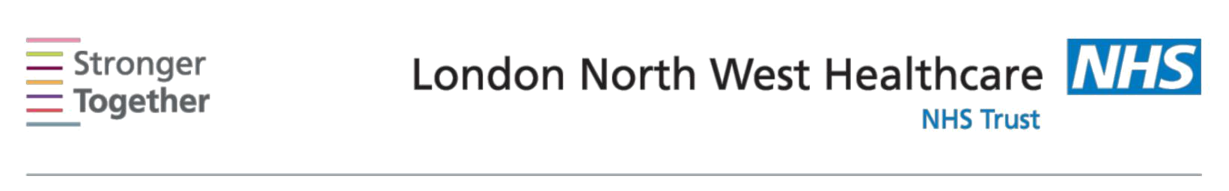
Nutrition and Dietetic Department, Northwick Park Hospital, Tel: 0208 869 2666

First line advice:
10 Steps to Healthy Eating
1. Eat regular & balanced meals

To maintain a healthy weight it is important not to skip meals and to have three meals spaced evenly throughout the day.

2. Include starchy carbohydrates at each meal

Include starchy carbohydrate foods at each of your meals such as bread, rice, chapatti, pasta, potatoes, cereals, plantain, yam or couscous. Choose wholegrain varieties where possible as these have more fibre which will help with digestion.

3. Reduce intake of saturated fat

Eat less fat, particularly saturated fat e.g. cakes, crisps, pastry, takeaway food. Use mono-unsaturated fats like olive oil and rapeseed oil, as these types of fat are better for your heart health. Grill, steam or bake foods instead of frying.

4. Increase intake of protein

Include 2-3 portions of protein foods per day such as meat, fish, poultry, eggs, beans and lentils. These provide protein, iron, B-group vitamins, zinc and magnesium, which are needed for the growth and repair of body tissues.

5. Increase fruit and vegetable intake

Aim for at least 5 portions of fruit and vegetables per day. These provide vitamins and minerals, and contain dietary fibre to help aid constipation as well as reduce the risk of some cancers, stroke and heart disease.

6. Reduce intake of sugary foods

Cut back on foods such as cakes, chocolate, sweets, biscuits, sugary cereals and pastry as they can be high in sugar and fat. Choose diet or no added sugar drinks.

7. Choose low fat dairy foods

Include 2-3 portions of dairy foods per day such as milk, cheese and yoghurt, to provide calcium, protein, vitamins B12, A and D. These are important for strong bones and teeth.

8. Cut down on your salt intake

Reduce salt in your diet to 6g (1 tsp) or less a day. Too much salt can increase blood pressure, which increases your risk of heart disease & stroke.

9. Increase your exercise

All activity causes you to burn calories and is beneficial for weight loss. Aim for 30 min/day minimum.

Tips for increasing exercise:
- Walk to the station or get off the bus a few stops earlier.
- Use the stairs instead of lifts.
- Make it a group thing – aerobics, swimming, dancing or walking clubs.
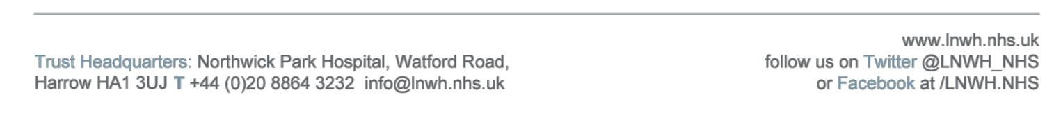
Information for patients

  - You can exercise at home too e.g. gardening, fitness DVDs.

- Limit your alcohol intake
Guidelines for men and women

How many units? | What is a unit?
Men & Women | Small glass wine (125ml) | = 1.5 units
2-3 units per day | 1 pints of beer | = 2.5-3.5 units
 | 50ml fortified wine | = 1 unit

- Have at least 2 alcohol free days a week.

The Eat Well Plate
A balanced diet includes a variety of all the different food groups.

The plate below gives you an idea about the amounts of each food group you should eat to have a balanced diet in a typical day.
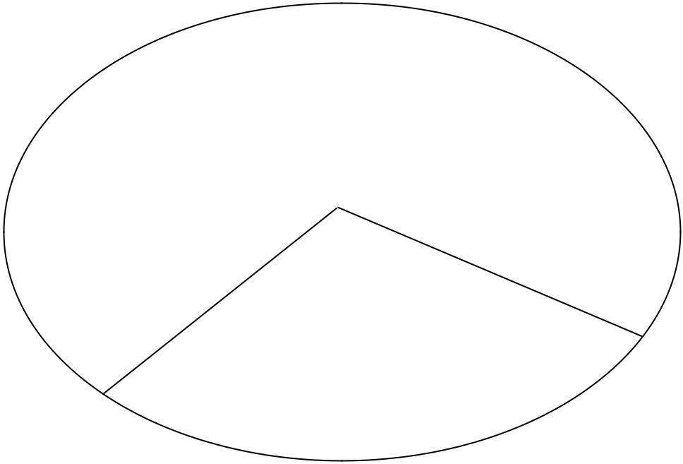
 |  |  | Bread, rice
 |  |  | pasta and
Fruit and |  |  | pasta and
Fruit and |  |  | other starchy
vegetables |  |  | other starchy
vegetables |  |  | foods

Meat, fish, bean, nuts eggs and dairy sources of protein

Healthy Eating Tips

- Copy the plate above - try to make sure your lunch and dinner plate are the same proportions as the Eat Well Plate above.
- Eat your fruit and vegetables - aim to eat a variety of colours and try to include
a portion at each meal. Fresh, frozen & tinned all count towards your 5-a-day!

- Keep hydrated – being hydrated improves concentration, prevents constipation, urinary tract infections and helps with all body processes.

- Snack healthy – choose low fat, low sugar options e.g. fruit, low fat yoghurt or vegetable sticks with dip.

This information leaflet was produced by the Community Dietitians at The London North West Healthcare NHS Trust, Northwick Park Hospital, Watford Rd, Harrow, HA1 3UJ
This information sheet was produced by the Community Dietitians at Northwick Park Hospital and is intended to be given by a health professional only. It is not a substitute for proper medical diagnosis or dietary advice given by a Registered Dietitian. The advice is not appropriate for certain medical conditions such as diets that require the exclusion or restriction of particular foods. If in doubt, please check with your medical practitioner. Last review: February 2017 Review date: February 2019

