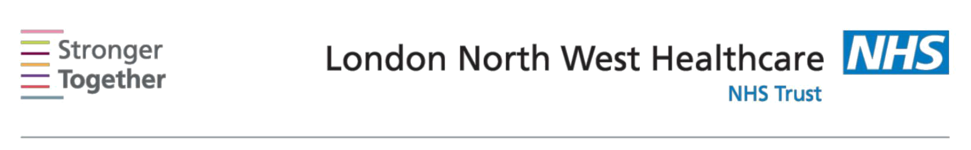
Nutrition and Dietetic Department, Northwick Park Hospital, Tel: 0208 869 2666

First line advice:
For patients with Diabetes
This information sheet has been provided to give you basic initial information about what to do if you have been diagnosed with Diabetes. It is only intended for use until you can see a Dietitian who will help plan your personal diet. Ensure your GP has booked you an appointment with the Dietitian at the time you receive this sheet.

A healthy, well balanced diet and regular exercise will help you to control your diabetes. You can get off to a good start by taking these 7 steps to eating a healthy diet.

Eat regular This includes bread, pasta, potatoes, chapatti, rice and cereals. meals based Try to choose slowly absorbed varieties of these foods such as on granary/multigrain bread, wholegrain cereals such as Special K, starchy foods Fruit & Fibre, Weetabix or no added sugar muesli, porridge oats,

basmati rice, sweet potatoes, plantains or waxy/new potatoes.

Include 1 item at each meal in the day but watch your portions as this may worsen your diabetes blood glucose control and cause weight gain.

Cut down on Avoid sugary foods (such as sweet biscuits, cakes, sweets, Indian sugar sweets and chocolate) and do not add sugar, gur or honey to food

or drinks.

Use diet, sugar-free or low calorie squashes/fizzy drinks instead of full sugar drinks and fruit juice as these can cause blood glucose levels to rise quickly.

Take less Cut down on saturated fats as this is linked with heart disease. saturated fat Avoid butter and ghee and choose olive based or low fat spreads

instead.

Use olive or rapeseed oil in cooking (but use in moderation as these will contribute to weight gain). Minimise the amount of frying you do by adopting low fat cooking methods such as grilling, boiling, poaching, steaming or oven baking.

Information for patients

Switch to low fat dairy products such as half fat cheese, skimmed or semi skimmed milk and low fat yoghurts.

Remove visible fat and skin from meat and poultry and avoid processed meat/fish products such as salami, pate, and pies. Avoid high fat meals options such as battered fish/meat.

Snacks such as sponge cakes, cream cakes, biscuits, chocolate, Bombay mix, fried crisps etc are also high in fat so should not be eaten regularly.
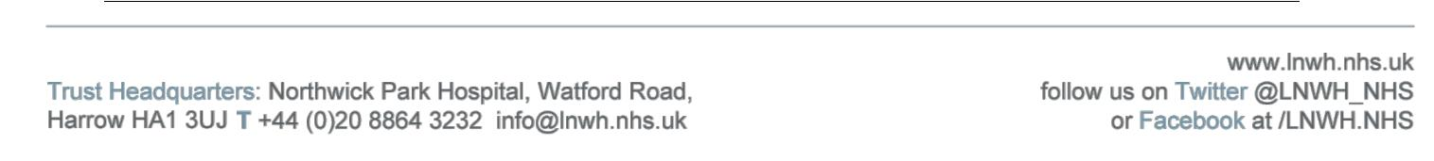

Enjoy plenty of vegetables and aim for 3-4 servings of fruit per day

Include fruit and/or vegetables at every meal. All fruits are suitable but spread them out through the day. You could also try fruit or raw vegetables as a snack between your meals.

Limit your Both men and women should not drink more than 14 units of alcohol intake alcohol each week. The 14-units should not be ‘saved up’ for 1 or

2 days but instead split over 3 or more days. A good way to reduce alcohol intake is to have several alcohol free days per week. 1 unit of alcohol is half-pint beer, a small glass (125mls) of wine, or single pub measure of spirits.

Never drink alcohol on an empty stomach and avoid binge drinking.

Choose low-calorie diet mixers and be aware that alcohol can contribute to weight gain.

Use less salt Avoid sprinkling salt on your meals and reduce salt added in cooking. Choose fresh foods where possible as processed foods usually have a high salt content. Soups, crisps, savoury snacks, soya sauce, Marmite, gravy granules and stock cubes are all high in salt. Experiment with flavouring foods using herbs and spices, vinegars or lemon juice instead of salt and stock cubes.

Increase your Try to walk more or start a new activity - this will help control your physical blood glucose levels as well as your weight.

activity!
Aim for at least 30 minutes per day for five days a week.

Check with your doctor before taking on any new exercise

Remember, if your doctor has prescribed tablets or insulin to control your blood glucose levels, you must continue to take these as advised, in addition to the above suggestions.

This information leaflet was produced by the Community Dietitians at The London North West Healthcare NHS Trust, Northwick Park Hospital, Watford Rd, Harrow, HA1 3UJ

This information sheet was produced by the Community Dietitians at Northwick Park Hospital and is intended to be given by a health professional only. It is not a substitute for proper medical diagnosis or dietary advice given by a Registered Dietitian. The advice is not appropriate for certain medical conditions such as diets that require the exclusion or restriction of particular foods. If in doubt, please check with your medical practitioner.

Last review June 2017

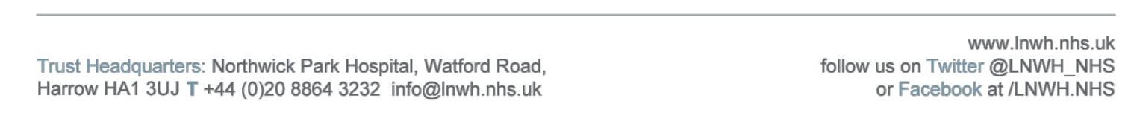
Review date June 2019 Reference:DM2017

