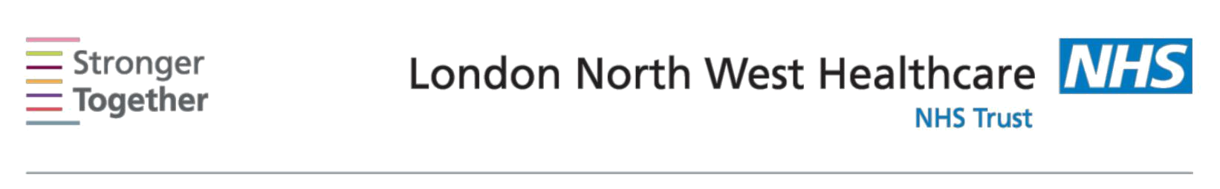
Nutrition and Dietetic Department, Northwick Park Hospital, Tel: 0208 869 2666

First line advice:
For Patients with High Cholesterol
This information sheet has been provided to give you basic initial information about what to do if you have raised cholesterol levels. Raised blood cholesterol is linked with atherosclerosis (narrowing or blocking of blood vessels) which increases risk of conditions such as heart attacks and stroke. This information sheet is only intended for use until you can see a dietitian who will help plan your personal diet. Ensure your GP has booked you an appointment with a dietitian at the time you receive this sheet.

What is Cholesterol?

Cholesterol is a fatty substance which is found in the blood. Cholesterol plays an important role in essential body cell functions. However, having too much increases your risk of heart disease.

There are two main types:

LDL – This can build up in artery walls leading to narrowing and blockage and can cause heart disease. We should aim to keep this low.

HDL – This helps to clear cholesterol from the body and is protective against heart disease. We should try to increase this level if it is low.

 | Cardio Protective Diet
Reduce your | Saturated fats come from animal sources such as butter, lard,
saturated fat | ghee, hard cheese, and fatty meats and meat products. They are
 | also used in the manufacture of cakes and biscuits. Coconut oil
 | and palm oil are also high in saturated fats.
Choose | Monounsaturated fats come from olive and rapeseed oil, avocado,
unsaturated | nuts (macadamia, almond, cashew, peanuts, brazil, chestnuts) and
fats | seeds, olive oil spreads and some margarine. Try to use this kind
 | of fat in cooking.
 | Polyunsaturated fats come from corn, sunflower, and soya oil, nuts
 | (walnuts, pine nuts) and seeds, and some margarine.
Include | Aim to have one portion of oily fish per week. This could include
sources of | salmon, herring, trout, mackerel, fresh tuna, pilchards, sardines.
Omega-3
Avoid trans | These are altered forms of Poly- and Mono-unsaturated fats. They
fats | appear on labels as ‘hydrogenated Vegetable oils’ and are usually
 | found in cakes, biscuits, chocolate, pastry, sauces, oils use
 | repeatedly for deep frying, and shortenings.
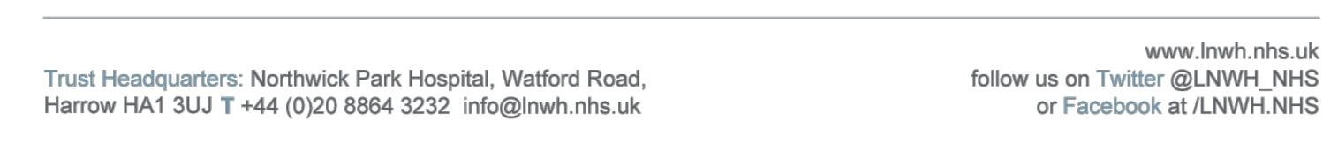

Information for patients

Include high | Soluble fibre comes from oats, pulses e.g. beans, lentils,
fibre foods, | chickpeas, and fruits and vegetables. They can help to lower
especially | cholesterol when consumed daily.
soluble fibre
Get your 5 a | These are a good source of antioxidants. Aim to take a variety of
day (fruit and | fruit and vegetables on a daily basis. A portion is a handful or 80g.
vegetables) | They can be fresh, dried or tinned. Juice can count as one portion.
Increase your | Aim for regular exercise on a daily basis and consider losing
activity and | weight if you are overweight.
control your
weight
 | Other important information for a healthy heart
Reduce salt | Avoid sprinkling salt on your meals and reduce salt added in
intake | cooking. Choose fresh foods where possible as processed foods
 | usually have a high salt content. Experiment with flavouring foods
 | using herbs and spices, vinegars or lemon juice instead of salt and
 | stock cubes.
Take alcohol in | Both men and women should not drink more than 14 units of
moderation | alcohol each week. The 14-units should not be ‘saved up’ for 1 or
 | 2 days but instead split over 3 or more days. A good way to reduce
 | alcohol intake is to have several alcohol free days per week. 1 unit
 | of alcohol is half-pint beer, a small glass (125mls) of wine, or
 | single pub measure of spirits.
Reduce your | Avoid sugary foods and do not add sugar or honey to food or
sugar intake | drinks.

This information leaflet was produced by the Community Dietitians at The North West London Hospitals NHS Trust, Northwick Park Hospital, Watford Rd, Harrow, HA1 3UJ

