Virtual Baby Feeding Postnatal Group

This is a free virtual class run by an Infant Feeding Lead, a Lactation Consultant and Health Visitor.

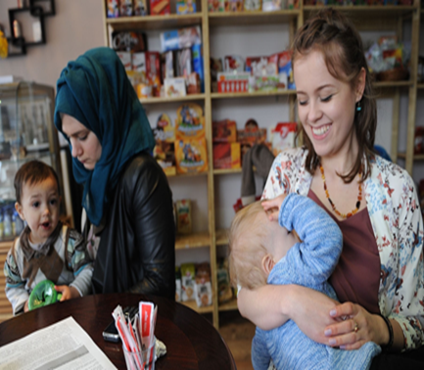

All new families are welcome. Classes last about 90 minutes and run most Tuesday mornings at 10am.
We will support you with any breastfeeding challenges or questions that you have. We also discuss baby’s brain development and normal baby behaviour. It’s All Things Baby!
To book a space please email Julie Peris (Infant Feeding Lead in Harrow) on j.peris@nhs.net

