How To Make Breastfeeding Easy And Enjoyable!
Virtual Group Antenatal Baby Feeding Classes
This is a free virtual class run by an Infant Feeding Lead, a Lactation Consultant and Health Visitor.
All pregnant mothers and partners welcome. Classes last about 2 hours and there will be a short break during the class. You will learn about…
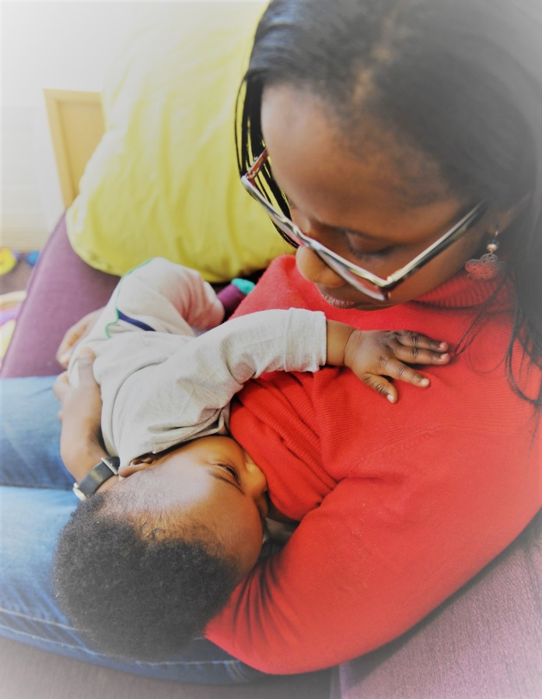

- The First Feed
- Establishing Breastfeeding
- Building A Milk Supply
- Different Ways to Hold Baby
- Common Breastfeeding Problems
- Responsive Feeding
- Pumping & expressing
- Baby Sleep
- Bottle Feeding
- Your Baby’s Brain
There will be time for any questions you may have. Classes run in the evening: 7pm to 9pm. The classes may overrun if we are a bit chatty!

To book a space please email Julie Peris (Infant Feeding Lead in Harrow) on j.peris@nhs.net or call 07889232460

